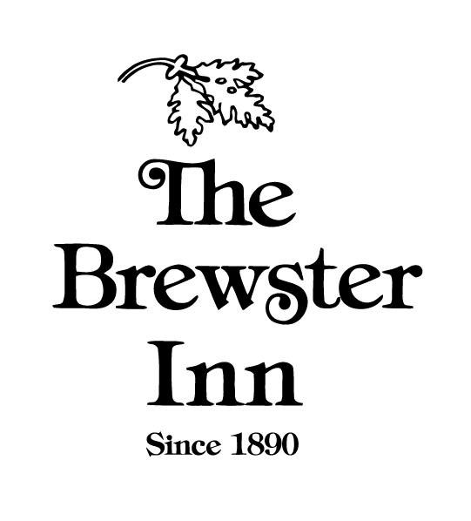

Wedding Sit-Down Reception
( Max 130) * uodated 8/18

Allows your guests to enjoy this special day relaxing as they are waited on by our dedicated staff. Sit back and enjoy culinary excellence from our DiRoNA award-winning restaurant in our elegant lakeside 1890’s stately historic mansion.

$120.00 to $140.00 pp (based on guest count)
Plus 8% tax and 20% gratuity

INCLUDES
Rustic Cheese Board
1 Salad Per Person
1 Entrée Per Person
3 Passed Hors d’oeuvres
Coffee & Tea Station
Premium Open Bar (4 Hours)

INCLUDES
A dedicated wedding planner
Customized menu prepared by our Executive Chef
4-hour use of space
Day of event management team
Site set up and breakdown
Seasonally protected patio space
Photography space
Tables, chairs, china, flatware, glassware
White linens
Complimentary on-site parking
Overnight room block for 2-days (contract set up, guests to pay own)
Table numbers
Complimentary cake cutting service
Hors d’oeuvres
Start it off right! Create an event that is uniquely you with mix and match hot and cold butlered hors d’oeuvres.
(Price below is per piece, 100 piece minimum per choice)

Sushi Stacks 2.50
Thai Rice Puff Topped with Tuna or Beef Tartar 2.00
Caprese Bites with a balsamic glaze 2.00
Tempura Vegetable Cones with Flavored Aioli 2.00
Mini Lobster Rolls 2.50
Deep Fried Mac & Cheese Bites 2.00
Watermelon, Parmigiano Reggiano & Prosciutto Stacks 2.00
Mini Beef Yorkshire Puddings 2.50
Mini Grilled Cheese's with Tomato Soup Shooters 2.50
Rock Shrimp Soft-shell Tacos with Seasonal Salsa 2.00
Smoked Salmon & Cucumber Skewers 2.50
Vegetable Crudite Shooters with Blue Cheese Dip 2.50
Meatballs with Asian Dipping Sauce (Pork, Beef, or Veal) 2.50
Gourmet Deviled Eggs 1.50
New Zealand Lamb Ribs with a mint chimichurri sauce 3.00
Petite Buffalo Chicken Wings & Blue Cheese Mousse 2.50
Lemongrass Shrimp Skewers 3.00
Smoked Salmon cups with crème fraiche 2.50
Mini Hushpuppies over Seafood / Clam Chowder Shooters 2.50
Beef Carpaccio Spoonfuls 2.50
Seasonal Fruit Skewers 2.00
Pork Pot Stickers with Asian Dipping Sauce 2.00
Jonah Crab Cakes with Tangy Remoulade 2.50
Shrimp Cocktail Shooters 3.00
Diver Scallops Wrapped in Applewood Smoked Bacon 2.50
Artichoke Crab Tartlet 2.00

Signature Brewster Sit Down Package
The signature package includes the following selections of food items, but can be upgraded depending on the bride and groom’s preference. *

Salads
Seasonal Fruit Salad
Romaine with seasonal fruit, sliced almonds with a choice of house made dressing

Caesar Salad
with freshly grated aged parmesan & homemade croutons

Salad Upgrades
Roth Blue Salad
field greens, toasted walnuts, red grapes, Roth blue cheese & a house-made balsamic vinaigrette
$5.00

Asiago Cheese Cup Salad
offers a chef’s choice of seasonal greens and ingredients.
$5.00

Sorbet Intermezzo
Luscious, yet refreshing fruit sorbet beautifully presented between courses.
$2.50

* Selections will be indicated on plate card

Entrees
Choose up to 3-5 entrée options for your guests.*

Truffle Encrusted Bigeye Hawaiian Tuna
balsamic teriyaki, shichimi aioli, sautéed spinach & fresh handmade pasta

Ponzu Marinated Chilean Sea Bass
tomatillo mojo, cilantro chimichurri & island rice

Bay Of Fundy Salmon
apple & arugula salad, sweet potato mash, toasted pecans

Lobster Pappardelle Pasta
pomodoro tomatoes, fennel, fresh chilies & garden basil

Brewster Inn Shrimp Scampi
tossed with tomatoes, asiago cheese, portobello mushrooms & hand-made pasta

Parker House Cracker Encrusted Scrod
lemon butter sauce, Chantilly potatoes & seasonal vegetables

The Brewster Inn Veal Atlantis
hand cut veal and Maine lobster served on a bed of wild greens & sauce of tarragon beurre blanc

Pan Seared Tournedos of Beef
to order Burgundy cream sauce with Chantilly potatoes

Chicken Francaise
sautéed with lemon, capers and white wine, fresh saffron pasta & seared spinach

Grilled Filet Mignon
36-hour reduced port wine demi glace, Chantilly potatoes and seasonal vegetables
Maine Lobster with drawn butter add on $10

New Zealand Grass Fed Rack of Lamb
rosemary balsamic glaze & whipped garlic potatoes

Center-Cut 16 oz Angus Choice Strip Steak
oven roasted exotic mushrooms and sweet onions, asiago cheese dauphine potatoes & beef glace

* Selections will be indicated on plate card. Meat will require a temperature.

Signature Brewster Bar Package
Our highly experienced bartenders will serve your guests for the entire duration of your 4-hour reception. Bar will include premium spirits, draft and bottled beers along with selections from our house bottles of wine.*

Premium Open Bar
Bar will include Absolut vodka, Tanqueray gin, Bacardi rum, Captain Morgan rum, Malibu rum, Jose Cuervo tequila, Canadian Club, Seagram's Seven, Jack Daniel's, Dewar's scotch. Beer will include bottled selections Corona, Blue, Blue Light, Bud, Bud Light and Sam Adams on draft. Wines include our house cabernet, merlot, chardonnay, white zinfandel, & pinot gris.

Bar Upgrade Options

Top Shelf Open Bar
Bar will include Grey Goose vodka, Bombay Sapphire gin, Tanqueray 10 gin, Pyrat rum, Patron Silver 1800 tequila, Maker's Mark bourbon, Crown Royal Canadian whisky, Johnny Walker Black scotch whisky, Jameson's Irish whisky, Courvoisier cognac, Bailey's Irish Cream, Kahlua rum liqueur, Grand Marnier Cordon Rouge, Amaretto DiSarrono. Beer will include imported and domestic bottle selections, all Brewster drafts. Wines will include Raymond cabernet, Columbia Crest merlot, Sonoma Cutrer chardonnay, Penfolds shiraz, & Gavi di Gavi.
Additional cost of $10.00 per guest

Wedding Cocktail
What is more uniquely you than having your very own signature bride and groom cocktails! Let us know your favorite drink or leave the creativity up to us – this libation is sure to get the party started!
Price Varies

Champagne Toast
Toast the new bride and groom with our house champagne.
$5.00 per person

Wine Tasting Presentation
Create a truly memorable experience with a Sommelier led private tasting with a special curated collection of unique bottles from our award-winning wine cellar.
Price Varies

* The Brewster Inn is happy to accommodate special requests for specific selections of beer, wine or liquor. Prices will vary based on selection and consumption.

Cake & Dessert
After your cake cutting ceremony the cake will be served immediately to your guests at no additional charge.

Sweet Samplings
An irresistible display of our pastry chef’s finest desserts, truffles and petite pastries.
(price per piece)

Assorted Chocolate Truffles 2.00
Cake Pops with flavored fondant icing 2.00
French Macaroons 2.00
Individual S'mores 2.00
Chocolate Mousse 2.50
Zabaglione Cups 2.50
Mini Cupcakes 2.00
Petifores 2.50
Mini Cream Puffs 2.00

Send Off Brunch

Make your wedding last!
Get one last chance to see everyone before the festivities come to an end.

carved meats
broiled salmon
salmon cakes
polenta cakes with mushroom ragu
chipotle maple sausage
applewood smoked bacon
Belgian waffles with whipped cream
home fries
scrambled eggs
mixed green salads
omelets made to order
pasta salads
sticky buns
sweet breads
croissants
fresh fruit
crème brulee French toast
homemade assorted seasonal desserts

$29 per person

Wedding Contacts

Barbara Ianuzi
Wedding Manager
Barbara@thebrewsterinn.com
(315) 655-9232

Jason Wright
Executive Chef
Chefs@thebrewsterinn.com
(315) 655-9232

